FLOWCHART BANTUSESAMA
User/Volunteer :
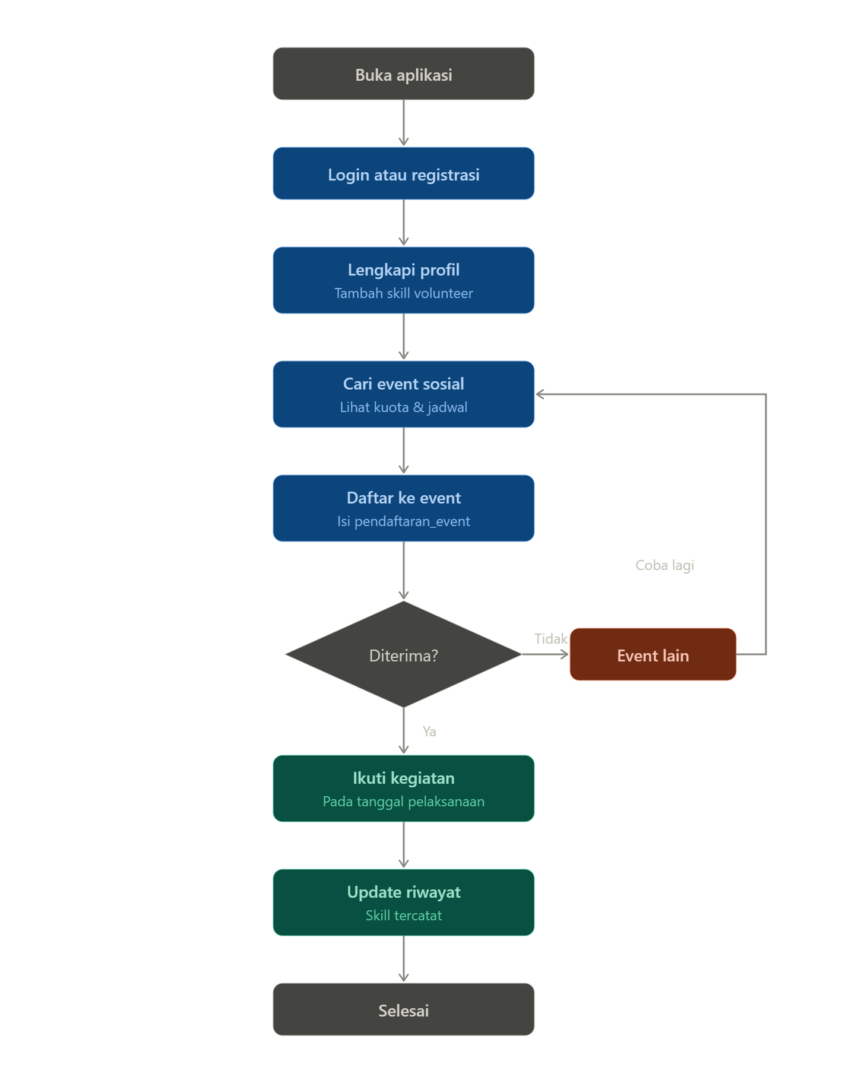
Bisnis/ Organisasi :
